
“TITLE”
“APPLICATION OF INFORMATION AND COMMUNICATION TECHNOLOGIES”
“PROJECT REPORT”
SEMESTER 1ST
SECTION A
SUBMITTED TO
SIR KHALID
SUBMITTED BY
AREEBA FATIMA
Roll No:
25-CS-221
Date: 03-02-2026
TABLE OF CONTENT
- Title Page
- Table of Contents
- Executive Summary (Abstract)
- Introduction
- Project Background
- Objective
- Scope
- System Requirements
- Hardware Requirements
- Software Requirements
- System Design
- Flowchart
- Implementation
- Technologies Used
- Code Structure
- Results and Discussion
- Screenshots
- Challenges
- Appendices
- Source Code

EXECUTIVE SUMMARY:
The Green Technology Showcase is a web-based project designed to provide information about environmentally friendly technologies. The website highlights innovations such as renewable energy, green computing, and sustainable practices. The platform is built using HTML, CSS, and JavaScript, offering a structured and interactive interface. Users can navigate through Home, About, Technologies, and Contact pages to access information and submit inquiries. The project demonstrates the practical application of front-end web development technologies to create an informative and functional website.

INTRODUCTION:

Project Background
Environmental sustainability is a critical concern in modern society. Green technologies, such as solar and wind energy, help reduce the environmental impact of human activities. This project was developed to provide a platform for learning about these technologies, presenting information in a structured and accessible manner.

Objective
- To create a website that presents information about green technologies.
- To design a clear, structured interface with text, images, and tables.
- To implement interactive features such as a contact form with validation.

Scope
- The website is static and accessible on desktops, tablets, and mobile devices.
- It includes four main pages: Home, About, Technologies, and Contact.
- Users can view detailed information about technologies, see images, and submit messages through the contact form.

SYSTEM REQUIREMENTS

Hardware Requirements
Minimum:
- Processor: Intel i3 or equivalent
- RAM: 4 GB
- Storage: 100 MB free space
- Display: 1024×768
Recommended:
- Processor: Intel i5 or equivalent
- RAM: 8 GB
- Storage: 500 MB free space
- Display: 1366×768 or higher

Software Requirements
Front-end:
- HTML, CSS, JavaScript
Back-end:
- Not required (static website)
Development Tools:
- IDE/Code Editor: Visual Studio Code, Sublime Text, or Notepad++
- Web Browser: Chrome, Firefox, Edge
SYSTEM DESIGN
Flowchart of Website Navigation
Start
↓
Homepage (index.html) loads
↓
User selects a page from navigation bar
↓
[About Page] → Display project background and images
[Technologies Page] → Display technology cards and table of benefits
[Contact Page] → Display form for user input
↓
If Contact Form Submitted → Validate inputs using JavaScript
↓
Show success or error message
↓
End
Explanation:
The flowchart illustrates the workflow of the website, showing the interaction between navigation, page content, and the contact form validation process.

IMPLEMENTATION:

Technologies Used
- HTML (Hypertext Markup Language) – Provides the structure and content of all pages.
- CSS (Cascading Style Sheets) – Used for styling elements, layout, colors, and responsive design.
- JavaScript – Implements interactivity, including contact form validation.
Code Structure:
File Name | Description
index.html | Homepage with welcome message and navigation buttons
about.html | Page providing project background and purpose
technologies.html | Page displaying green technologies using cards and tables
contact.html | Page with interactive contact form
style.css | Stylesheet defining design and layout for all pages
script.js | JavaScript for form validation
Images | Local images for technologies (solar-energy.jpg, green-energy.jpg)
Folder Example:
- project-folder
- index.html
- about.html
- technologies.html
- contact.html
- style.css
- script.js
- solar-energy.jpg
- green-energy.jpg
RESULTS AND DISCUSSION:
SCREENSHOTS
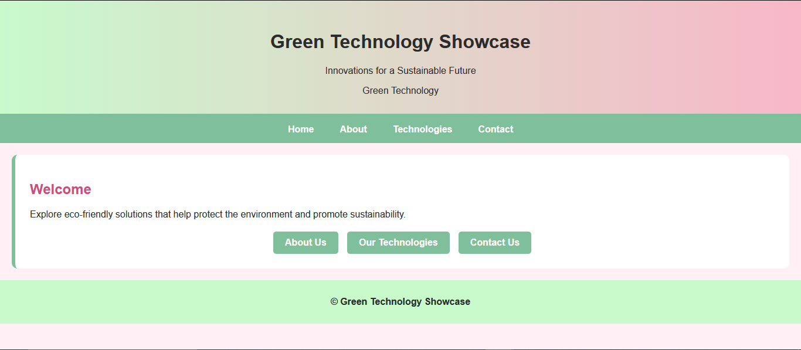

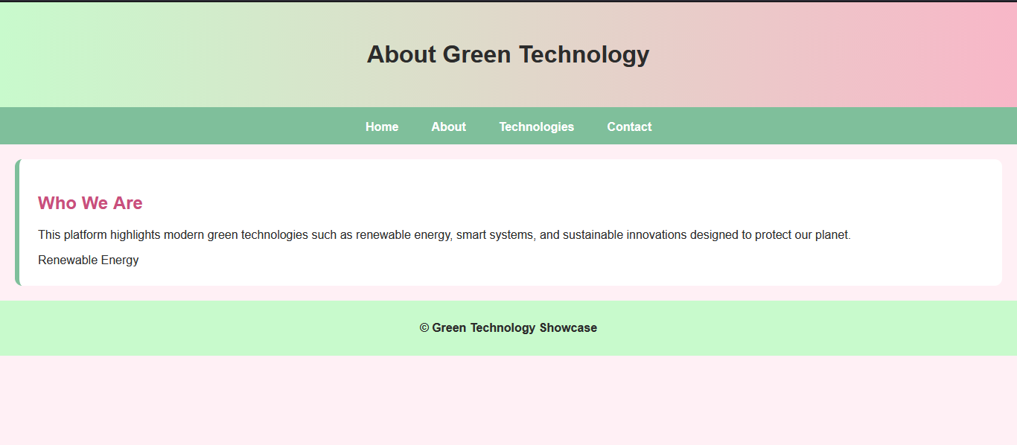


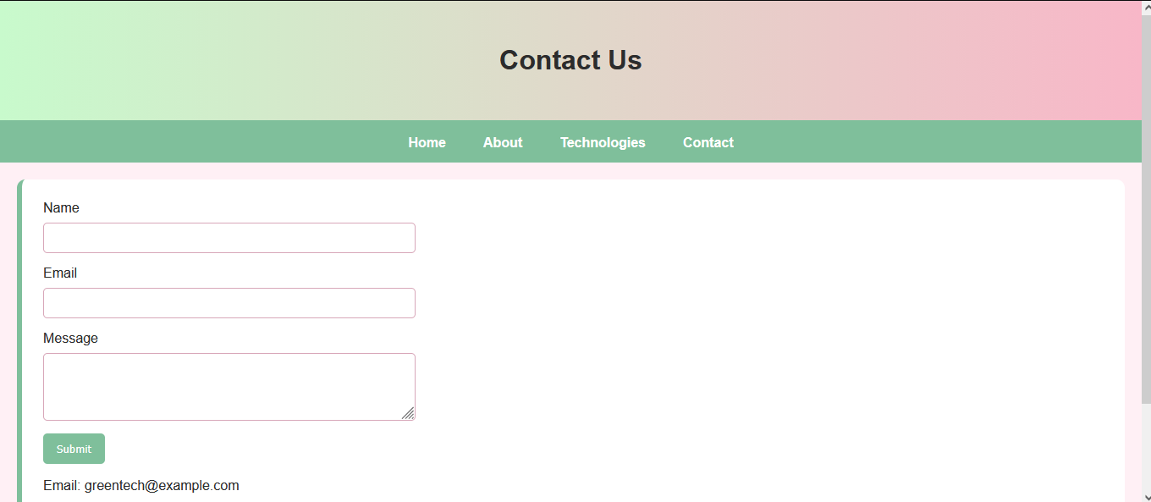

CHALLENGES AND SOLUTIONS:
Challenge | Solution
Form validation | Implemented JavaScript to check empty fields and validate email format
Responsive layout | Used CSS flexbox and percentage widths for cards and buttons
Consistent design | Applied gradients and a uniform color palette across pages
Table readability | Styled tables with borders and alternate row colors
Discussion:
The project demonstrates the use of front-end technologies to create a functional website. It highlights how HTML, CSS, and JavaScript can be combined to provide an informative and interactive platform for users interested in green technologies.
APPENDICES:
https://github.com/AreebaFatima822/AICT-PROJECT-HTML-CSS

